**Requirements and User Stories**

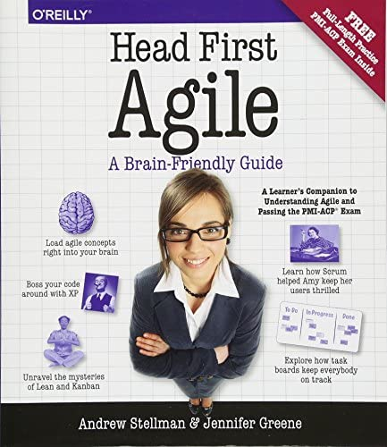

We needed to understand the process of Scrum, so we read the first chapters of a book called “Head First Agile: A Brain-Friendly Guide to Agile Principles, Ideas, and Real-World Practices”. Here we understood how other teams organize their work based on User Stories and we made them based on this type of cards:

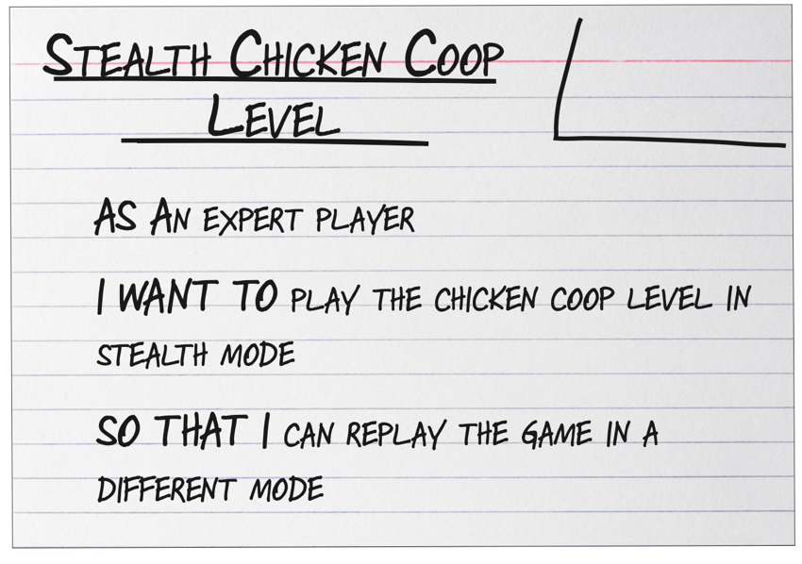

This are the User Stories we determined we needed to develop:

***User Story 1****As the Restaurant Owner  
I want to be able to create personal and secure users for the cashiers  
So that they can register sales and give Invoices to the clients*

***User Story 2****As the Restaurant Owner  
I want to be able to manage the restaurant menu  
So that Invoices have the details of items that were bought*

***User Story 3****As the Cashier  
I want to be able to create and search clients by their ID or RUC  
So that I can associate them to the Invoice*

***User Story 4****As the Cashier  
I want to be able to generate a detailed Invoice and send it by Email  
So that the Client has the Invoice*